**Northwind Traders DB :**

* **Suppliers**: Suppliers and vendors of Northwind
* **Customers**: Customers who buy products from Northwind
* **Employees**: Employee details of Northwind traders
* **Products**: Product information
* **Shippers**: The details of the shippers who ship the products from the traders to the end-customers
* **Orders and Order_Details**: Sales Order transactions taking place between the customers & the company

**Required insights :**

**1- overview Report :**  
**KPI’s :**   
  
1-Net sales

Select sum((od.UnitPrice*od.Quantity)-(od.UnitPrice*od.Quantity*od.Discount)) As Net_sales

From [Order Details] As od

2-Count of customers

Select count(cst.customerid)

from Customers as cst

3- count of orders

Select count(ord.OrderID)

from Orders as ord

4 - Avg days to ship the order   
  
create view days_to_ship_the_order as(

Select DATEDIFF(day,ord.OrderDate,ord.ShippedDate) As duration_to_ship_the_order,ord.OrderID

from Orders as ord

group by ord.OrderID,ord.OrderDate,ord.ShippedDate)

Select AVG(days.duration_to_ship_the_order)

from days_to_ship_the_order as days

**Charts :**   
Net sales over the time (months )

Create view Net_sales_over_the_time_month_and_years As(

Select count (od.orderid)As No_of_orders, sum((od.UnitPrice*od.Quantity)-(od.UnitPrice*od.Quantity*od.Discount)) As Net_sales,MONTH(ord.OrderDate)as Month,year(ord.OrderDate)as Year

from [Order Details]as od

left join orders as ord on ord.OrderID=od.OrderID

group by MONTH(ord.OrderDate),year(ord.OrderDate)

)

Select *

from Net_sales_over_the_time_month_and_years

order by month

Top 5 customers by net sales

Create view Top_5_customers_per_net_sales As(

Select top 5 ord.CustomerID, sum((od.UnitPrice*od.Quantity)-(od.UnitPrice*od.Quantity*od.Discount)) As Net_sales

from [Order Details]as od

left join orders as ord on ord.OrderID=od.OrderID

group by ord.CustomerID

order by Net_sales desc)

select*

from Top_5_customers_per_net_sales

Top 5 products by net sales

Create view Top_5_products_per_net_sales As(

Select top 5 p.ProductName, sum((od.UnitPrice*od.Quantity)-(od.UnitPrice*od.Quantity*od.Discount)) As Net_sales

from [Order Details]as od

left join orders as ord on ord.OrderID=od.OrderID

join Products as p on p.ProductID=od.ProductID

group by p.ProductName

order by Net_sales desc)

select*

from Top_5_products_per_net_sales

Net sales by countries ( present it using maps is a plus )

Create View Net_sales_for_countries As(

Select sum((od.UnitPrice*od.Quantity)-(od.UnitPrice*od.Quantity*od.Discount)) As Net_sales ,ord.ShipCountry

From [Order Details] As od

left join orders as ord on ord.OrderID=od.OrderID

group by ord.ShipCountry)

Select*

from Net_sales_for_countries

order by Net_sales Desc ___________________________________________________________________

**2-Revenue Report:**

1. Net profit

Create view profits As(

Select od.orderid,count (od.orderid)As No_of_orders, sum((od.UnitPrice*od.Quantity)-(od.UnitPrice*od.Quantity*od.Discount)) As Net_sales ,sum(p.UnitPrice*od.Quantity)As unit_cost ,(sum((od.UnitPrice*od.Quantity)-(od.UnitPrice*od.Quantity*od.Discount))*.07) As profit, MONTH(o.OrderDate)as month

from [Order Details] as OD

left join Products as P

on p.ProductID=od.ProductID

join Orders as o

on o.OrderID=od.OrderID

group by od.orderid,o.Freight,o.OrderDate)

select sum(profit)

from profits

1. Total Discounts

Select sum(od.UnitPrice*od.Quantity*od.Discount)As discounts

from [Order Details] as OD

1. Shipping Cost

Select sum(o.Freight)As Shipping Cost

from orders as o

**Charts :**

Top 5 countries by net sales

Create view Top_5_countries_per_net_sales As(

Select top 5 ord.ShipCountry, sum((od.UnitPrice*od.Quantity)-(od.UnitPrice*od.Quantity*od.Discount)) As Net_sales

from [Order Details]as od

left join orders as ord on ord.OrderID=od.OrderID

group by ord.ShipCountry

order by Net_sales desc)

select*

from Top_5_countries_per_net_sales

Net sales , profits and discounts over the time

create view Net_sales_profits_discounts_over_the_times_per_months_years As (

Select sum((od.UnitPrice*od.Quantity)-(od.UnitPrice*od.Quantity*od.Discount)) As Net_sales ,(sum((od.UnitPrice*od.Quantity)-(od.UnitPrice*od.Quantity*od.Discount))*(.07)) As profit,sum(od.UnitPrice*od.Quantity*od.Discount) As Discount , MONTH(ord.OrderDate)as month,year(ord.OrderDate)as year

from [Order Details] as OD

left join Products as P

on p.ProductID=od.ProductID

join Orders as ord

on ord.OrderID=od.OrderID

group by MONTH(ord.OrderDate),year(ord.OrderDate)

)

Select *

from Net_sales_profits_discounts_over_the_times_per_months_years

order by year

Top 5 countries by discounts

Create View Top_scountries_perDiscount as (

Select top 5 sum(od.UnitPrice*od.Quantity*od.Discount) As Discount ,ord.ShipCountry

from [Order Details] as OD

join Orders as ord

on ord.OrderID=od.OrderID

group by ord.ShipCountry)

Select * from Top_scountries_perDiscount

Pivot table to show the net sales , net profit and Net sales YOY for each countries.

create view YOY AS(

Select sum((od.UnitPrice*od.Quantity)-(od.UnitPrice*od.Quantity*od.Discount)) As Net_sales ,(sum((od.UnitPrice*od.Quantity)-(od.UnitPrice*od.Quantity*od.Discount))*(.07)) As profit,sum(od.UnitPrice*od.Quantity*od.Discount) As Discount ,ord.ShipCountry As Country, MONTH(ord.OrderDate)as month,year(ord.OrderDate)As year

from [Order Details] as OD

left join Products as P

on p.ProductID=od.ProductID

join Orders as ord

on ord.OrderID=od.OrderID

group by ord.ShipCountry,ord.OrderDate)

Select *

from YOY

**3- Customers Report :**

1- avg net sales per customer

2- avg profit per customer

1. avg shipping cost per customer

Select C.CustomerID,c.CompanyName,Avg (o.Freight) Avg_Frieght_cost,Avg((od.UnitPrice*od.Quantity)-(od.UnitPrice*od.Quantity*od.Discount)) As Avg_Net_sales ,(Avg((od.UnitPrice*od.Quantity)-(od.UnitPrice*od.Quantity*od.Discount))*.07) As Avg_profit,Avg(od.UnitPrice*od.Quantity*od.Discount) As Avg_Discount

from Customers as C

join orders As o

on c.CustomerID=o.CustomerID

join [Order Details] as od

on o.OrderID=od.OrderID

join Products as p

on od.ProductID=p.ProductID

group by C.CustomerID,c.CompanyName

**Charts :**

Count of customers over the time

create view Customer_over_years as (

Select count(c.customerid)as coustomer_count ,year(o.OrderDate)As year

from customers as c

left join Orders as O

on c.customerid=o.CustomerID

group by year(o.OrderDate))

Count of customers by countries

Create View customers_by_countries As (

Select count(c.customerid)as coustomer_count ,o.ShipCountry as Country

from customers as c

left join Orders as O

on c.customerid=o.CustomerID

group by o.ShipCountry)

Select *

from customers_by_countries

Count of new customers and repeated customers ( new customers : who have not any purchases in 1996 or 1997 only in 1998 and they will be considered as new customers at that case )

alter table customers

add customer_type nvarchar(30)

update customers

set customer_type=(

Select case

when min (year(orderdate))<'1998' then 'loyal Customer'

else 'New customer'

end

from orders

where Orders.customerid=Customers.customerid

group by orders.customerid)

Select *

from Customers

create view customer_type as (

select customerid,customer_type

from Customers)

1. **Products report :**

1-Avg Net profit per order

2- Avg Shipping cost per order

3 - Avg Net sales per order

Select Avg((od.UnitPrice*od.Quantity)-(od.UnitPrice*od.Quantity*od.Discount)) As avg_Net_sales,

(Avg((od.UnitPrice*od.Quantity)-(od.UnitPrice*od.Quantity*od.Discount))*(.07)) As Avg_profit,

Avg(od.UnitPrice*od.Quantity*od.Discount) As Avg_Discount ,Avg(o.Freight) As Avg_fright

from [Order Details]as od

join orders as o

on od.orderid=o.OrderID

4-count of products

select count(productid)

from products

5-count of categories

select count(categoryid)

from products

6- percentage of discontinued products and products are selling

WITH ProductCounts AS (

SELECT

COUNT(*) OVER () AS total_products,

SUM(CASE WHEN discontinued <> 0 THEN 1 ELSE 0 END) OVER () AS discontinued_count,

SUM(CASE WHEN discontinued = 0 THEN 1 ELSE 0 END) OVER () AS selling_count

FROM products

),

PercentageCalculations AS (

SELECT

discontinued_count,

selling_count,

total_products,

(discontinued_count * 100.0 / total_products) AS discontinued_percentage,

(selling_count * 100.0 / total_products) AS selling_percentage

FROM ProductCounts

)

SELECT TOP 1

discontinued_count,

selling_count,

total_products,

FORMAT(discontinued_percentage, 'N2') AS discontinued_percentage,

FORMAT(selling_percentage, 'N2') AS selling_percentage

FROM PercentageCalculations;

**Charts** :

1-Top 5 products by net sales

Create view Top_5_products_per_net_sales As(

Select top 5 p.ProductName, sum((od.UnitPrice*od.Quantity)-(od.UnitPrice*od.Quantity*od.Discount)) As Net_sales

from [Order Details]as od

left join orders as ord on ord.OrderID=od.OrderID

join Products as p on p.ProductID=od.ProductID

group by p.ProductName

order by Net_sales desc)

2-Net sales and profits by categories

create view profit_netsales_by_Categories as(

Select Cat.CategoryName,sum((od.UnitPrice*od.Quantity)-(od.UnitPrice*od.Quantity*od.Discount)) As Net_sales,

(sum((od.UnitPrice*od.Quantity)-(od.UnitPrice*od.Quantity*od.Discount))*(.07)) As profit

from [Order Details] as od

join products as p on p.ProductID=od.ProductID

join Categories as cat on p.CategoryID=cat.CategoryID

group by Cat.CategoryName)

Select *

from profit_netsales_by_Categories

Create View Product_sales_profit as(

Select p.Productname,sum((od.UnitPrice*od.Quantity)-(od.UnitPrice*od.Quantity*od.Discount)) As Net_sales,

(sum((od.UnitPrice*od.Quantity)-(od.UnitPrice*od.Quantity*od.Discount))*(.07)) As profit

from [Order Details] as od

join products as p on p.ProductID=od.ProductID

group by p.Productname)

Select*

from Product_sales_profit

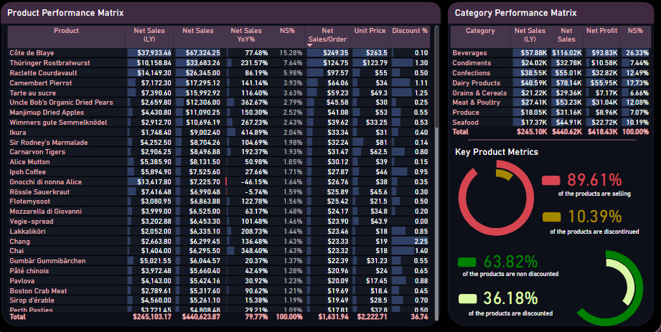

1. **Employee Report**

net sales per employee or avg , count Orders per employee or avg

Select (E.FirstName +' '+E.LastName) AS name, sum((od.UnitPrice*od.Quantity)-(od.UnitPrice*od.Quantity*od.Discount)) As Total_sales,

Avg((od.UnitPrice*od.Quantity)-(od.UnitPrice*od.Quantity*od.Discount)) As Avg_sales,

Count(od.orderid)As Count_of_orders ,

(sum((od.UnitPrice*od.Quantity)-(od.UnitPrice*od.Quantity*od.Discount))*(.07)) As profit

From [order details] as od

join orders as o

on od.orderid=o.orderid

join employees as e

on o.employeeid=e.employeeid

group by e.FirstName, e.LastName;

count of employees or avg

Select count(e.employeeid) as employees

from employees as e

count of supervisors or avg

Select COUNT(e.employeeid) AS Count_of_Supervisors

from Employees as e

where e.reportsto <5 or e.reportsto is NULL

**Charts :**

Monthly Net sales by employees //

Count of the orders and net sales by the employees (employee performance )

Create view Employee_sales_orders_profit_per_month as(

Select (E.FirstName +' '+E.LastName) AS name, sum((od.UnitPrice*od.Quantity)-(od.UnitPrice*od.Quantity*od.Discount)) As Total_sales,

Avg((od.UnitPrice*od.Quantity)-(od.UnitPrice*od.Quantity*od.Discount)) As Avg_sales,

sum(od.orderid)As Count_of_orders ,

(sum((od.UnitPrice*od.Quantity)-(od.UnitPrice*od.Quantity*od.Discount))*(.07)) As profit,MONTH(o.OrderDate)as month,year(o.OrderDate)As year

From [order details] as od

join orders as o

on od.orderid=o.orderid

join employees as e

on o.employeeid=e.employeeid

group by E.FirstName, E.LastName,MONTH(o.OrderDate),year(o.OrderDate))

Select* from Employee_sales_orders_profit_per_month

order by profit desc

Delayed orders and on time orders by employees

create view late_ontime_orders as (

Select e.FirstName + ' ' + e.LastName as Name, count(o.OrderID) as Count_of_Orders,

sum(case

when o.ShippedDate <= o.RequiredDate then 1

else 0

end) as Count_of_On_Time,

sum(case

when o.ShippedDate > o.RequiredDate then 1

else 0

end) as Count_of_Delayed

from Orders o

join Employees e on o.EmployeeID = e.EmployeeID

where ShippedDate IS NOT NULL

group by e.FirstName,e.LastName

)

Select*

from late_ontime_orders

order by name

1. **Shippers Report :**

Shipping cost by order

Select o.orderid,sum (o.Freight) fright_cost

from orders as o

group by o.orderid

Avg days to ship

create view days_to_ship_the_order as(

Select DATEDIFF(day,ord.OrderDate,ord.ShippedDate) As duration_to_ship_the_order,ord.OrderID

from Orders as ord

group by ord.OrderID,ord.OrderDate,ord.ShippedDate)

Select AVG(days.duration_to_ship_the_order)

from days_to_ship_the_order as days

**Charts :**

Shipping cost by the shippers

Create view Shipping_cost_per_company As(

Select s.companyname As company,sum (o.freight) as shipping_cost

from orders as o

join shippers as s

on s.shipperid=o.shipvia

group by s.companyname)

Select *

from Shipping_cost_per_company

order by shipping_cost DESC

On time vs delayed orders by shipper ( delivery performance )

create view delivery_performance as (

Select s.companyname As company,

sum(case

when o.ShippedDate <= o.RequiredDate then 1

else 0

end) as orderst_of_On_Time,

sum(case

when o.ShippedDate > o.RequiredDate then 1

else 0

end) as orders_Delayed

from orders as o

join shippers as s

on o.ShipVia=s.ShipperID

where ShippedDate IS NOT NULL

group by s.companyname

)

Select * from delivery_performance

Shipping cost by the countries and shippers

Create view shipcost_country_company As (

Select s.companyname As company,sum (o.Freight)As shipping_cost,o.shipcountry

from orders as o

join shippers as s

on o.ShipVia=s.ShipperID

group by s.companyname,o.shipcountry)

Select*

from shipcost_country_company

Shippers table to show the next details :

Create View Shipping_companies_performance_per_years as (

select s.CompanyName,count(o.orderid) count_of_orders,

sum(case

when o.ShippedDate <= o.RequiredDate then 1

else 0

end) as orderst_of_On_Time,

sum(case

when o.ShippedDate > o.RequiredDate then 1

else 0

end) as orders_Delayed,

AVG(DATEDIFF(day, o.OrderDate, o.ShippedDate)) AS Avg_Days_To_Ship,

( sum(od.UnitPrice * od.Quantity * p.UnitPrice) / SUM(od.Quantity)) AS Avg_Shipping_Cost_Per_Order,sum(od.UnitPrice * od.Quantity) AS Net_Sales,year(o.ShippedDate) as year

from Orders o

JOIN [Order Details] od

on o.OrderID = od.OrderID

join Products p

on od.ProductID = p.ProductID

JOIN Shippers s

on o.ShipVia = s.ShipperID

where o.ShippedDate IS NOT NULL

group by s.CompanyName,year(o.ShippedDate))

Select *

from Shipping_companies_performance_per_years

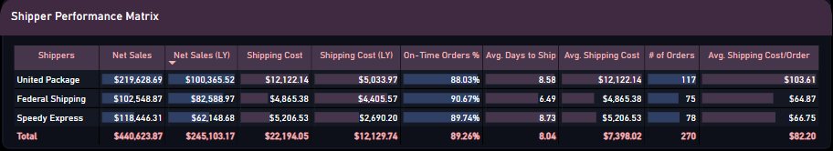Use Excel or power bi and the hints to build a Northwind_performance _ dashboard